KANSAS WESLEYAN UNIVERSITY
Division Council
Thursday, September 5, 2019
11:30 am - 12:30 pm in PH 320

Minutes

Present: Bill Backlin, Dorothy Hanna, Steve Hoekstra, Janeane Houchin, Damon Kraft (Chair), Barbara Marshall Nickell, Kristy Rodriguez.
Guest: Jasmin Dauner
Call to Order: Kraft called the meeting to order at 11:30 am. Minutes from 8/29/19 were approved.

Old Business
Program Prioritization
- Dr. Kraft went over the questions brought up at the last prioritization meeting on 9/3/19.
  - On August 25, 2019 – 15 attended
- On September 3, 2019 – 8 attended
- September 11 is next meeting
- The review group will each take an area to review.

New Business
SOAR
- There will be a SOAR debrief meeting in late September.
- Over 50% of our students enrolled past late July.

Discussion
- There are too many student attendees needing help at the same time.
- Student attendees need better understanding that the faculty SOAR representative is not their advisor.
- Students were reaching out to the faculty rep regarding changes which should have been to their advisor.
- Concerns were brought up about the number of dropped courses requested by students during the beginning of the FA19 semester.
- Making sure paperwork is done correctly is a must.
- Parents commented that it was more of an assembly line and would prefer a sit down to get to know their student’s advisor.

Recommendations for improvement
- Look at the goal/purpose
- Students should walk away with an understanding and comfort with the classes.
- Have a supplemental contract for divisional representation “Enrollment Specialist“which would be an incentive for faculty participation.
- Specify dates and times that person would be on contract.
- Students should know who their advisor is.
- It was suggested by the chairs to push the July SOAR to August and to place an emphasis on finalizing enrollments by May.
- Southwestern brings freshmen on campus 4 days before the start of classes and did academic workshops.
- We need the enrollment process done early and shaped before the end of summer.

2020-21 Schedule
FA20 – 40 LS courses – 7 are online.
- Additional NW needed
- Online concerns; we need shape and direction to ensure success for our online programs.

SP21 – 47 LS courses – 11 are online.
- NW classes online – of the 4, 2 are World Geography – 1 should be on-ground.
- When opening up enrollment, online students could have the option to enroll first.
- Cap limits need to be reviewed (lowered) not going over 49. Very few areas should be making changes to caps.

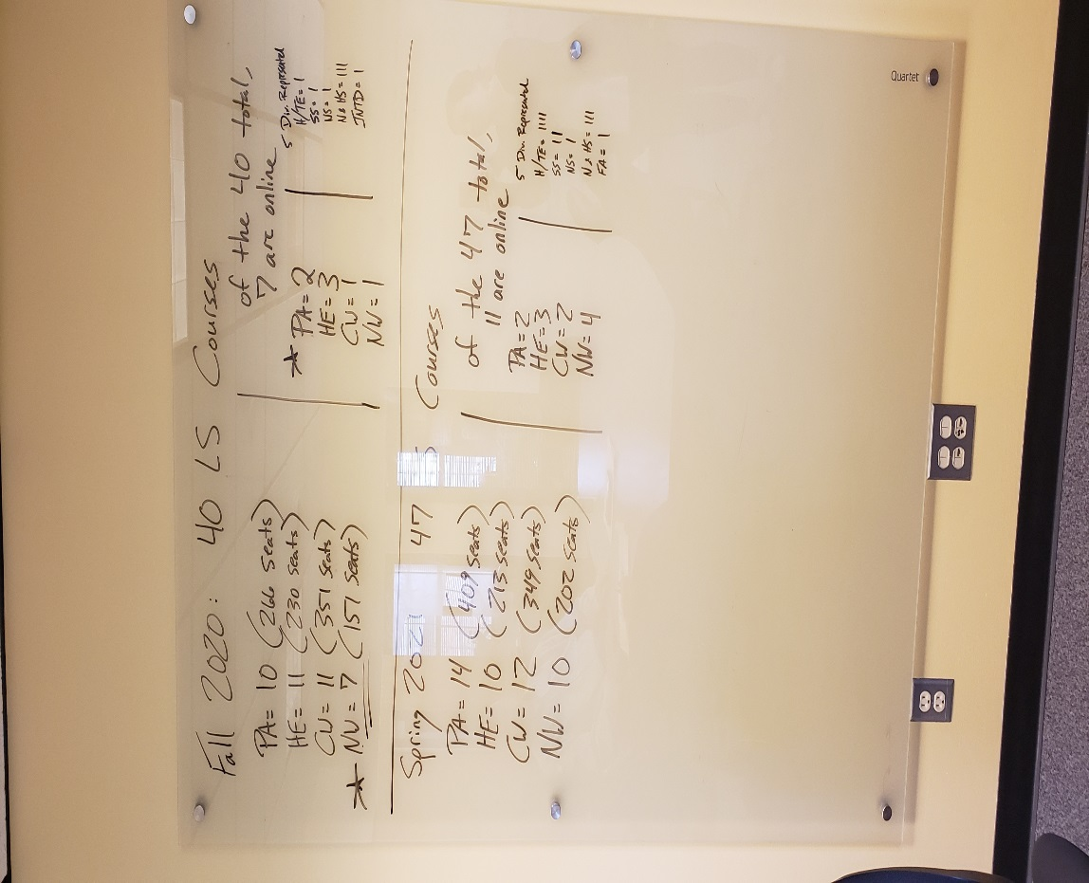

SOAR and schedule will be revisited next meeting.

Adjournment: Meeting was adjourned at 12:34 pm.

Respectfully submitted,
Kristan Hernandez
Minutes Recorder

