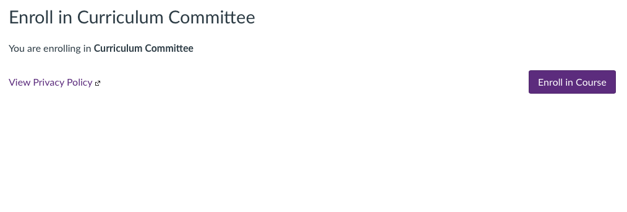
Enroll into Curriculum Committee Class using this link: https://kwu.instructure.com/enroll/RF463H

- Click on Enroll Course

3. On the home page you will find will find modules that contain your forms. You can also find the forms on the Intranet

4. Under the home page module, download the correct form and follow the curriculum process to completing your proposals.

5. Once all forms are completed, login into Canvas and go to assignments. Find the next open upcoming “assignment”. If the deadline has not passed, then click on the next upcoming submission date. You have to submit proposals (one week in advance of the meeting).

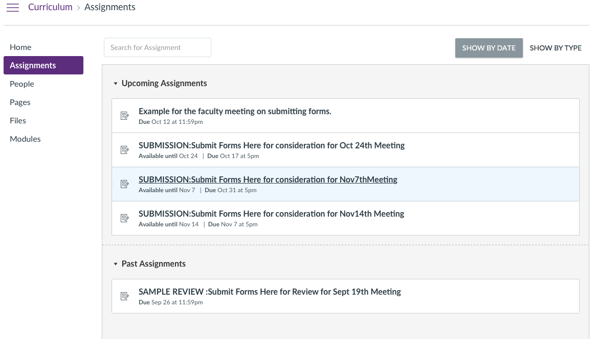

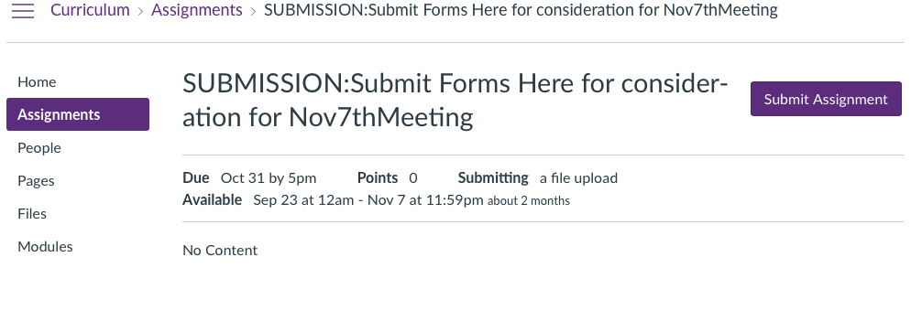

6. Click on submit assignment.

7. Click on File Upload. Choose your file(s). To load more than one program form or course form in the same submission you will need to hit the + symbol to add another file. That way all files get submitted at one time and not through a resubmission process. This will assure that the committee sees all the documents properly when reviewing. Please remember we would like to have minutes attached with your forms not as a separate file. Please then place in the comments the # of forms you are submitting at one time to assure they all get reviewed.
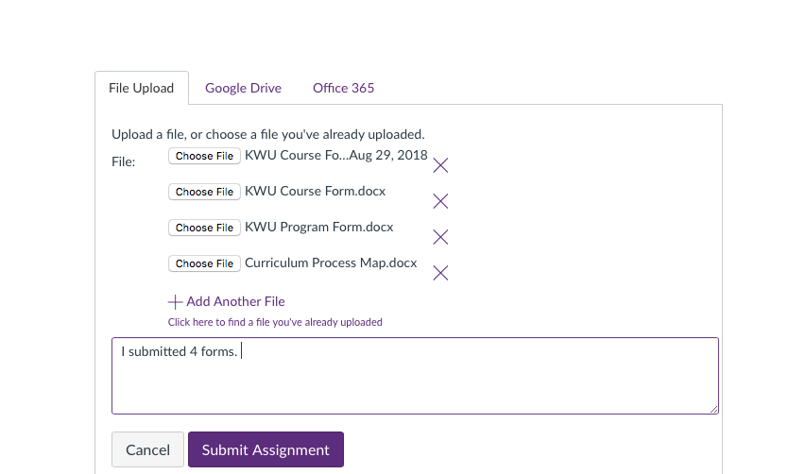

8. After you have submitted the documents, you can review the committee comments and find out if edits or adjustments are needed and if you need to re-submit the documents again. You do this by clicking on the assignment and then clicking “Submission Details” on the right hand side where your document(s) are placed. It is seen in purple. Note: if you click on the assignment all it does is download and open the document you submitted.
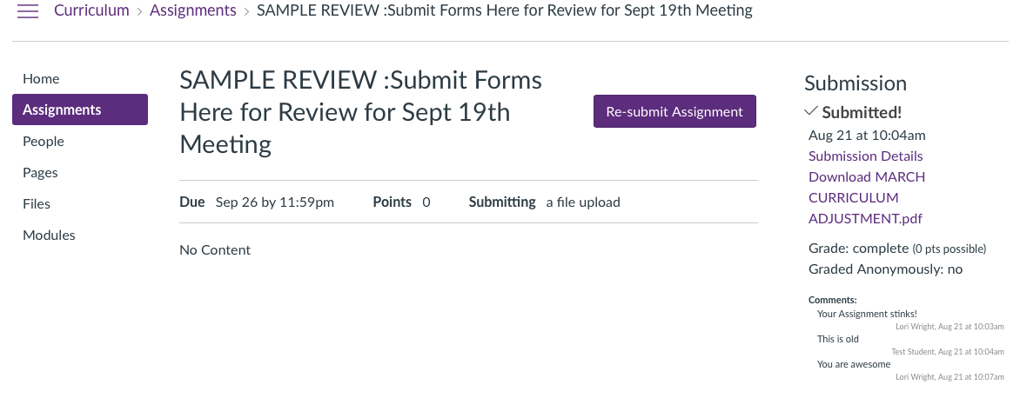
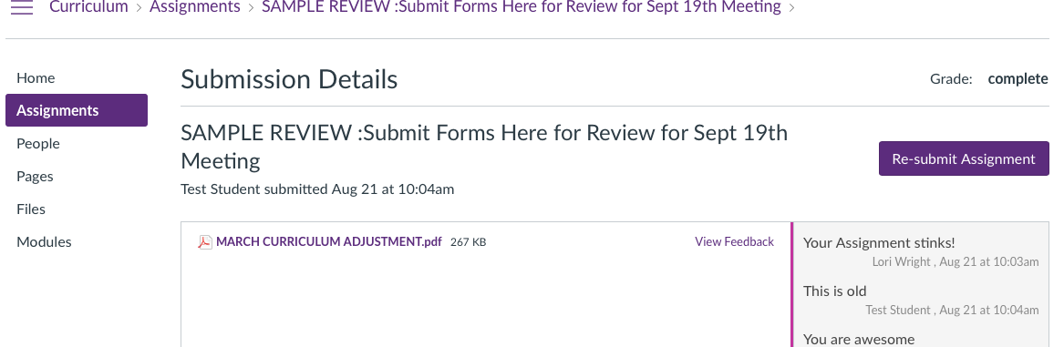
9. Click View Feedback

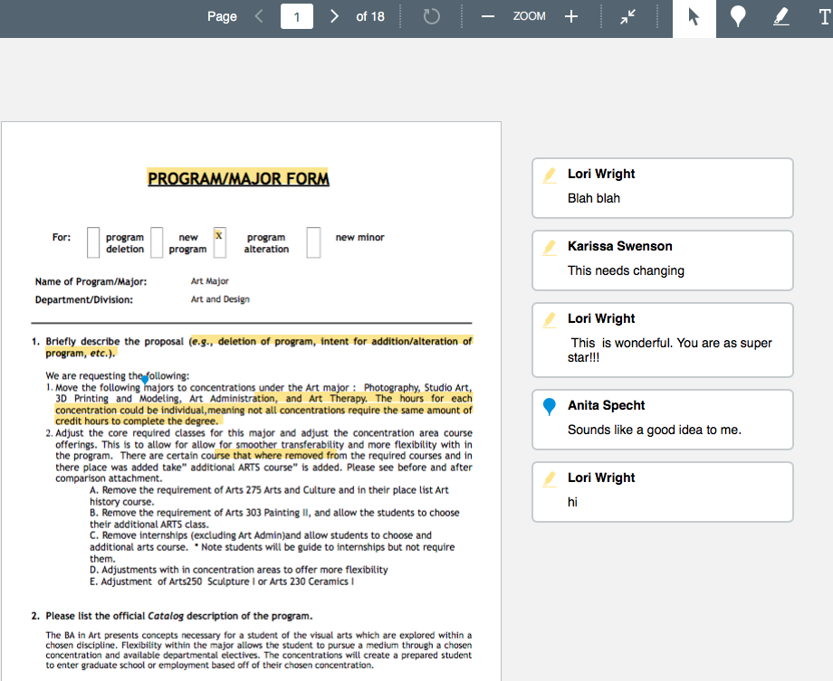
10. You should be able to see a small version of your document with any annotating the committee has done. You can then click on the down arrow with the line under it to download the annotated version or click on the diagonal arrows to get full screen. The forms should then look like the sample below. You will get to see comments and highlights where the committee may see concerns. You can ask questions using the comment section if you like.

11. If you are asked to resubmit something, you will be able to do that by going back to the assignment and clicking the submit document.

12. If, after the documents are discussed, in the meeting you are asked to come back and resubmit your documents, you will then need to do so in the next open Canvas submission assignment.

